**BONUS LAB ASSIGNMENT**

**(FIND THE IMPOSTER)**

Akshit Puri

Cyber Security, Loyalist College of Applied Arts and Technology

CYSE2001: Secure Network Infrastructure

Instructor: Peter Wheeler

28th September 2022

Firstly, we will keep all the Switch MAC address tables populated by typing "ping -t 10.9.9.255" on PC0's Command Prompt

Starting from Switch0, using ‘show mac address-table to trace the location of each

Malicious acting MAC addresses.

We have been informed that the following three MAC addresses are acting maliciously:

- 0006.2a55.34de

- 0000.0c07.be8e

- 0001.9666.3d1b

And by looking at the mac-address-table of Switch 0 we will get to know that all these maliciously acting mac addresses are connected to **Fast Ethernet 0/1.**

The Switch0’s FastEthernet0/1 is connected to Switch1

Now we must check the mac-address-table of Switch1 to trace the location of the suspicious mac-address.

by looking at the mac-address-table of Switch 1 we will get to know that all these maliciously acting mac addresses are connected to **Fast Ethernet 0/2.**

The Switch1’s FastEthernet0/2 is connected to Switch4

Now we must check the mac-address-table of Switch4 to trace the location of the suspicious mac-address.

From this mac-address table, we can see that the malicious mac-address is connected to which Fast Ethernet Port.

- 0006.2a55.34de = FastEthernet 0/5

- 0000.0c07.be8e = FastEthernet 0/3

- 0001.9666.3d1b = FastEthernet 0/2

The Switch4’s FastEthernet0/5 is connected to Switch12

The Switch4’s FastEthernet0/3 is connected to Switch10

The Switch4’s FastEthernet0/2 is connected to Switch9

Now we must check the mac-address-table of Switch9, Switch10 & Switch12 to trace the location of the suspicious mac-address.

**SWITCH 12:**

by looking at the mac-address-table of Switch 12 we will get to know that the “0006.2a55.34de “ maliciously acting mac address is connected to **Fast Ethernet 0/7.**

The Switch12’s FastEthernet0/7 is connected to PC8

Now we shut down the port Fa0/7 of Switch 12 to disconnect from the ***0006.2a55.34de*** maliciously acting mac-address.

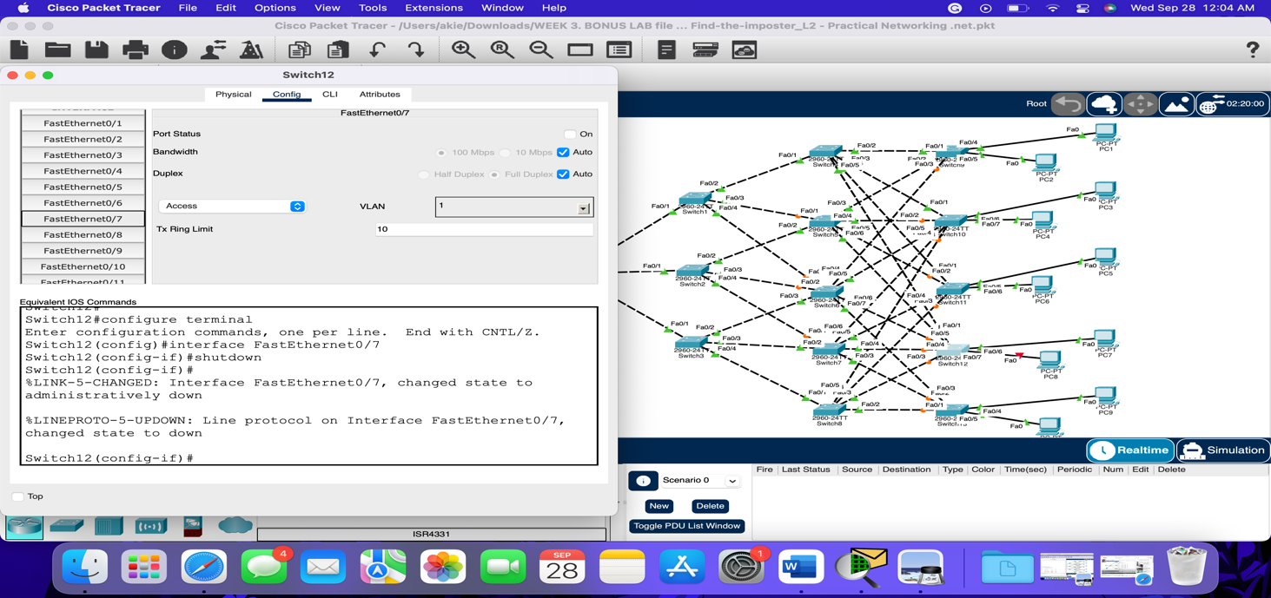

**SWITCH 10:**

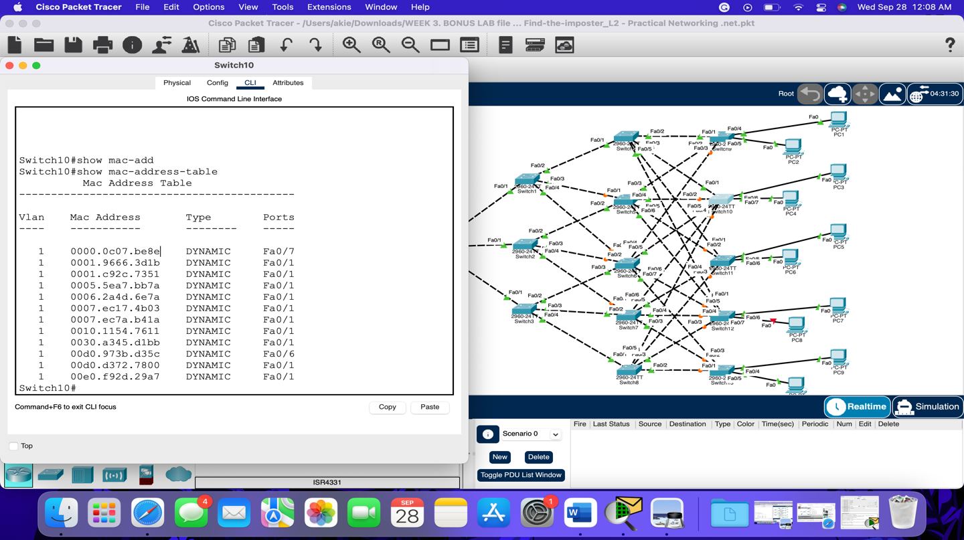

by looking at the mac-address-table of Switch 10 we will get to know that “0000.0c07.be8e” maliciously acting mac address is connected to **Fast Ethernet 0/7.**

The Switch10’s FastEthernet0/7 is connected to PC4

Now we shut down the port Fa0/7 of Switch 10 to disconnect from the ***0000.0c07.be8e*** maliciously acting mac-address.

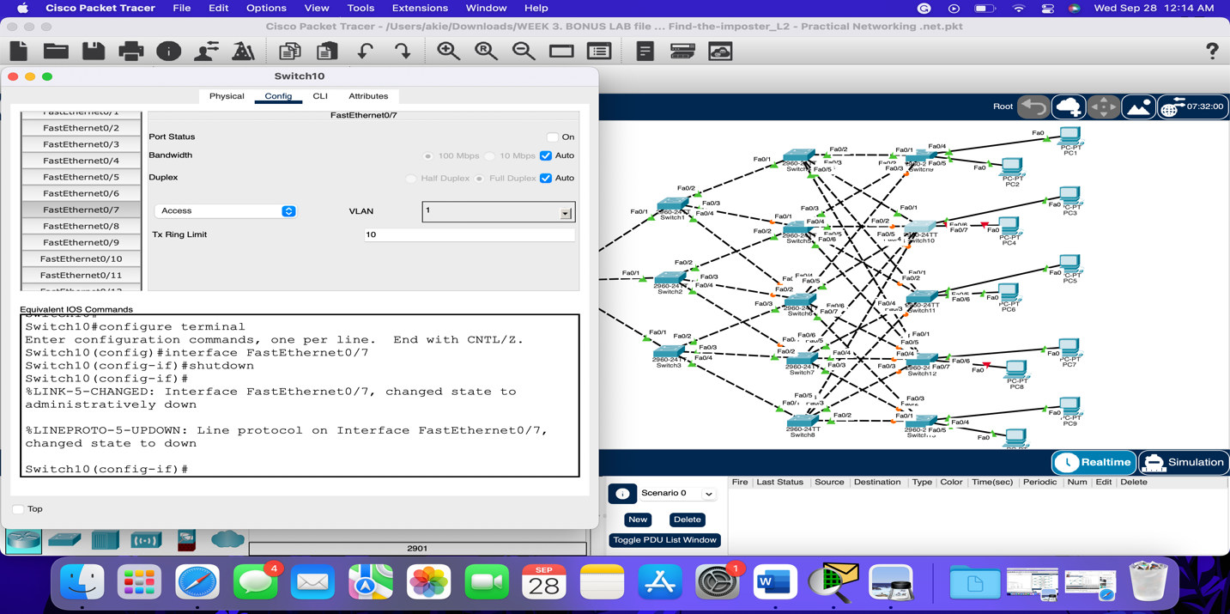

**SWITCH 9:**

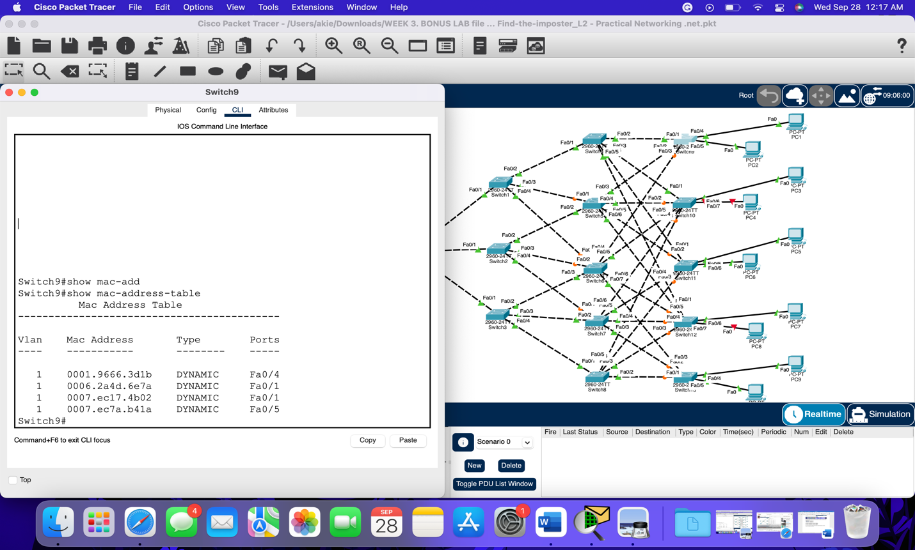

by looking at the mac-address-table of Switch 9 we will get to know that the “0001.9666.3d1b” maliciously acting mac address is connected to **Fast Ethernet 0/4.**

The Switch9’s FastEthernet0/4 is connected to PC1

Now we shut down the port Fa0/1 of Switch 9 to disconnect from the ***0001.9666.3d1b*** maliciously acting mac-address.

**Thus, the imposters are PC1, PC4 & PC8**. At Last, we can ping again from PC0.

Previously we are getting 11 ping responses in PC0 Command Prompt but now only 8 ping responses because 3 maliciously acting ports and disabled.

Also, the Mac-address table of Switch0 is not showing any Maliciously acting mac addresses.

